// SHELL PROGRAMMING

//SWAPPING VARIABLES

#!/bin/bash

echo "Enter first number"

read a

echo "Enter second number"

read b

echo "BEFORE SWAPPING"

echo " a = $a "

echo " b = $b "

a=$((a+b))

b=$((a-b))

a=$((a-b))

echo "AFTER SWAPPING"

echo " a = $a "

echo " b = $b "

//OUTPUT

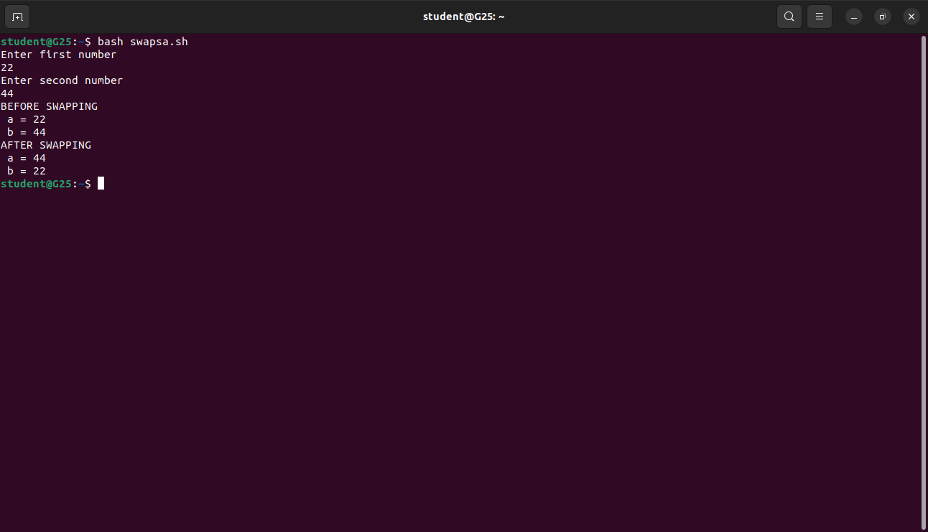

//AVERAGE OF TWO NUMBERS

#!/bin/bash

echo "Enter Size(N)"

read N

i=1

sum=0

echo "Enter Numbers"

while [ $i -le $N ]

do

read num

sum=$((sum + num))

i=$((i + 1))

done

avg=$(echo $sum / $N | bc -l)

echo $avg

// OUTPUT

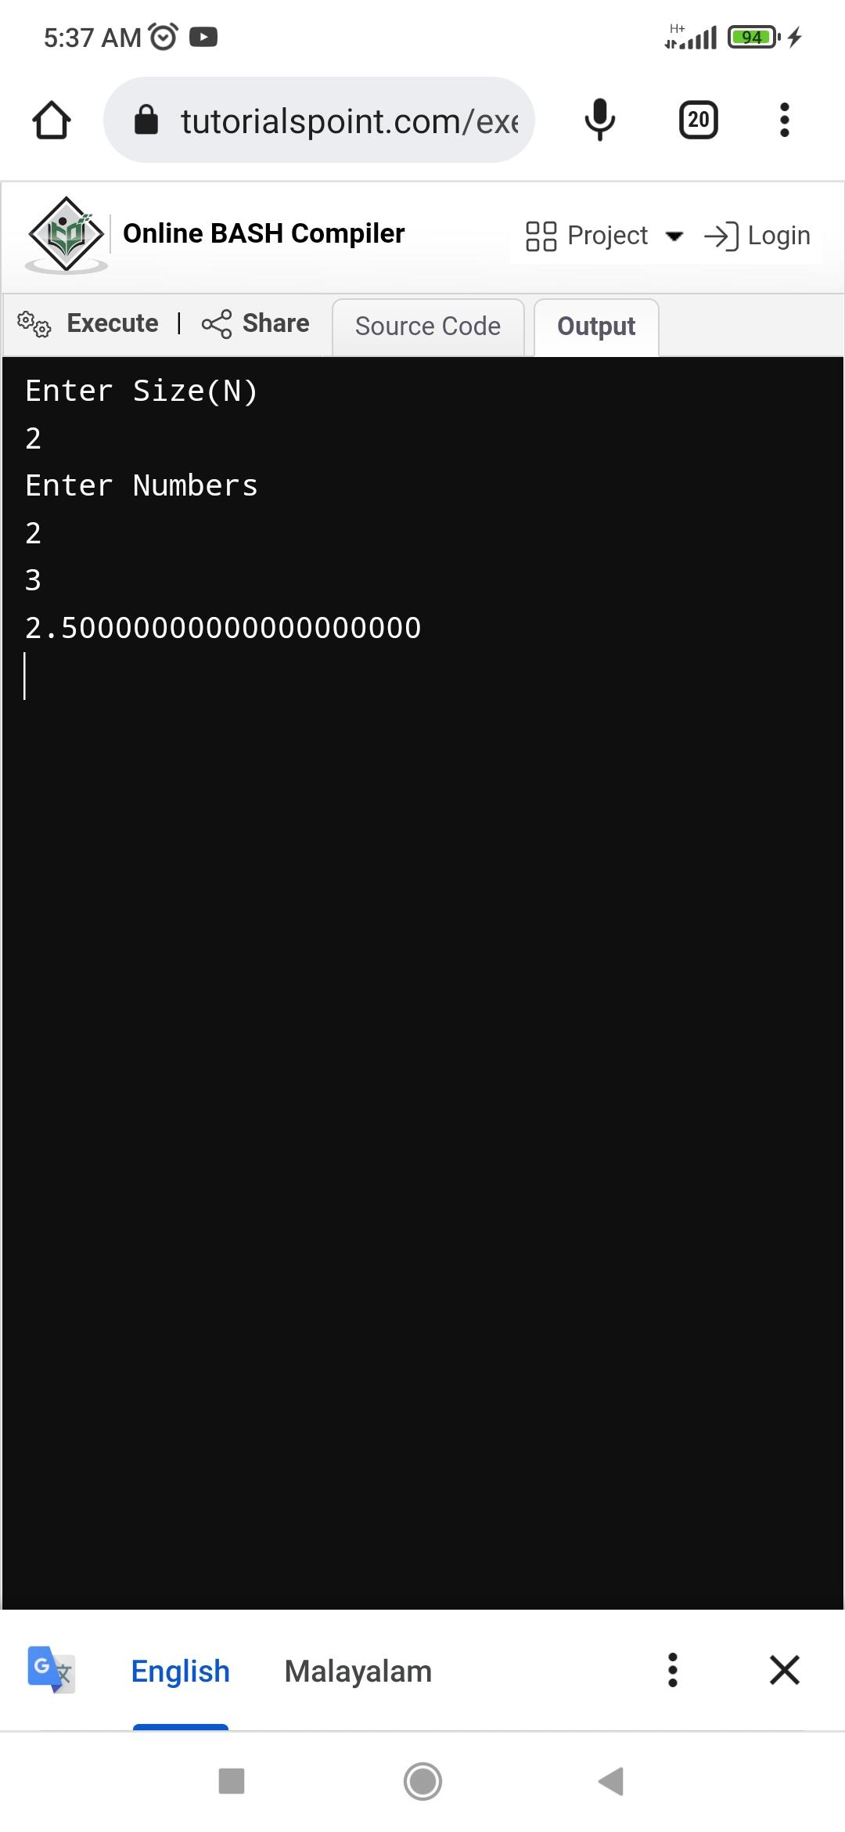

//REVERSE A STRING

#!/bin/bash

echo "Enter a String"

read string

len=${#string}

for ((i=len-1;i>=0;i--))

do

reverse+=${string:$i:1}

done

echo "Reversed String is : $reverse"

//OUTPUT

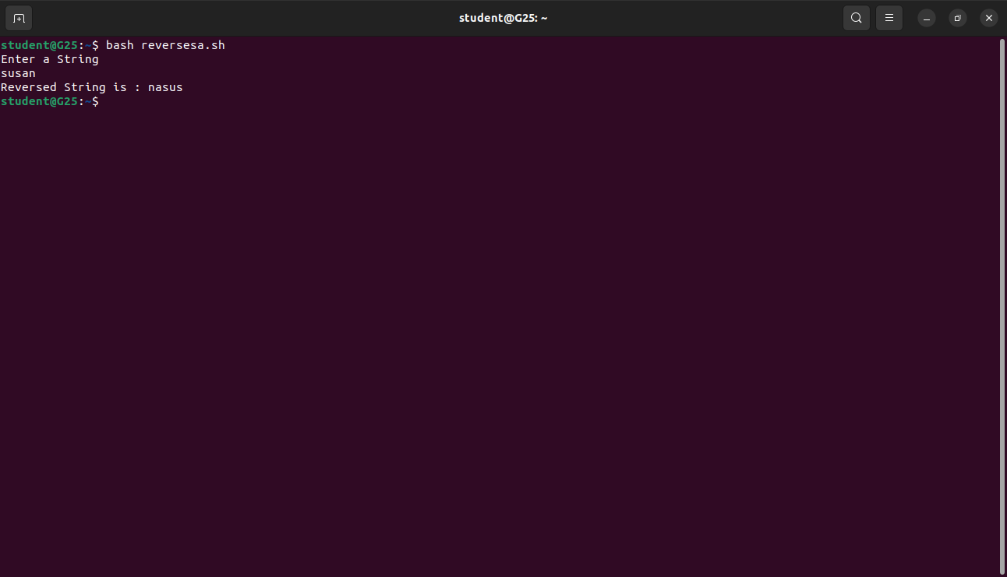

//PATTERN

#!/bin/bash

echo "Enter the number of lines to print"

read n

echo

for ((i=0; i<n; i++))

do

for ((j=1; j<=i+1; j++))

do

echo -n "$j "

done

echo

done

//OUTPUT

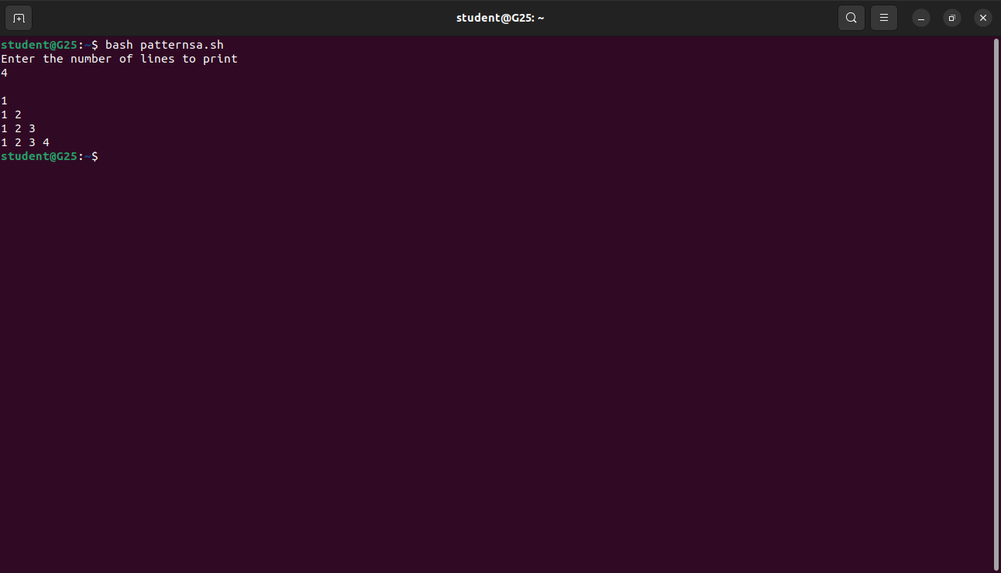

// FARHENHEIT TO CELSIUS TEMPERATURE

#!/bin/bash

echo "1. Farenheit to Degree Celsius"

echo "2. Degree Celsius to Farenheit"

read c

if ((c==1))

then

echo "Enter temp in Farenheit :"

read f

echo "Degree Celcius = "$(echo "scale=2; ($f-32)\*5/9" | bc)

elif ((c==2))  
then  
echo "Enter temp in Degree Celsius :"  
read c  
echo "Farenheit = "$(echo "scale=2; ($c\*9/5)+32" | bc)  
  
else  
echo "invalid choice"  
  
fi

//OUTPUT

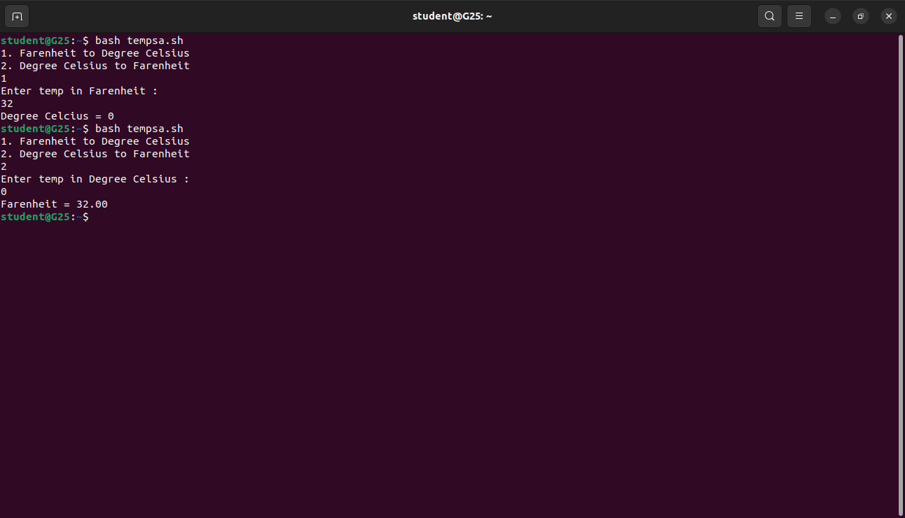

//LARGEST AMONG THREE NUMBERS

#!/bin/bash

echo "Enter three Numbers"

read num1

read num2

read num3

if ((num1>num2 && num1>num3))

then

echo "Largest is $num1"

elif ((num2>num3))

then

echo "Largest is $num2"

else

echo "Largest is $num3"

fi

//OUTPUT

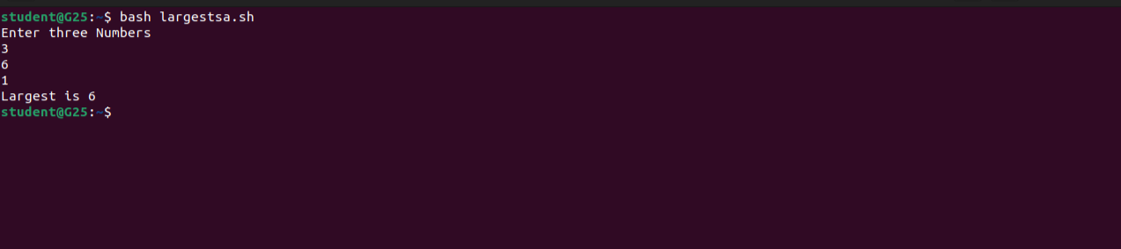

//CALCULATOR

#!/bin/bash

echo "Simple Calculator"

echo "Select Choice"

echo "1.Addition"

echo "2.Substraction"

echo "3.Multiplication"

echo "4.Division"

echo "0.exit"

c=1

while ((c!=0))

do

echo "Select Choice"

read c

case $c in

1)

echo "Enter two numbers"

read a

read b

echo "Sum is $((a+b))"

;;

2)

echo "Enter two numbers"

read a

read b

echo "Difference is $((a-b))"

;;

3)

echo "Enter two numbers"

read a

read b

echo "Product is $((a\*b))"

;;

4)

echo "Enter two numbers"

read a

read b

echo "Quotient is "$(echo "scale=4; $a/$b" | bc)

;; 0)

;;

\*)

echo "Invalid Choice"

esac

done

//OUTPUT

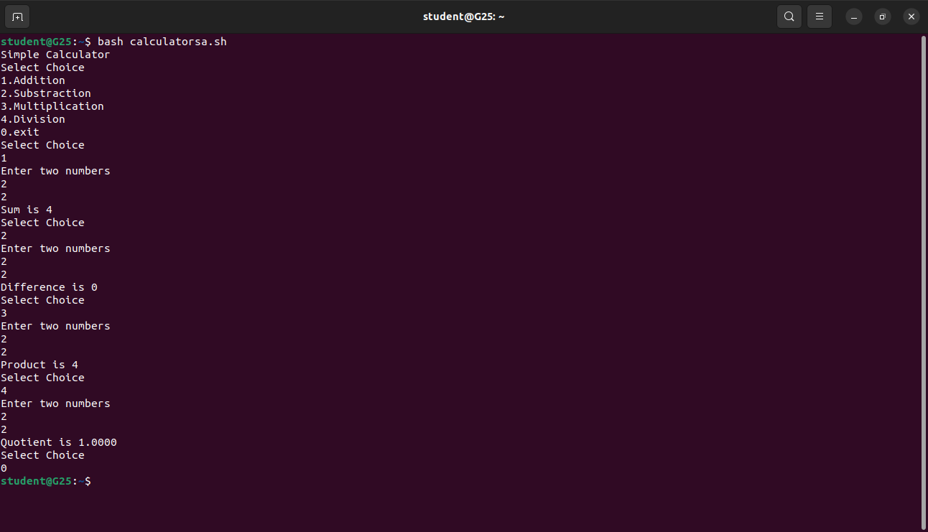

//REVERSE A NUMBER

#!/bin/bash

echo enter n

read n

num=0

while [ $n -gt 0 ]

do

num=$(expr $num \\* 10)

k=$(expr $n % 10)

num=$(expr $num + $k)

n=$(expr $n / 10)

done

echo number is $num

//OUTPUT

